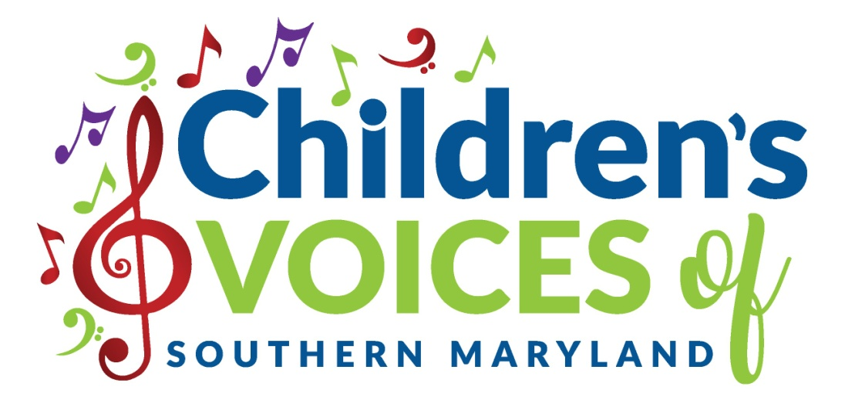
Registration Form for 2019-2020
Student’s name _______________________________________________________________
Date of Birth _______________________ Age ___________ T-shirt Size _________________
School attending ______________________________________Grade Level_____________
Previous choral experience or musical training (piano lessons, etc.): ___________________________________________________________________________
Home address _______________________________________________________________
City__________________________ State_______ Zip Code__________________________
Parent or guardian name _______________________________________________________
Daytime phone__________________________________ Cell phone_______________________
E-mail address ________________________________________________________________
Parent or guardian name ________________________________________________________
Daytime phone__________________________________ Cell phone_______________________
E-mail address __________________________________________________________________
Are there any personal circumstances of which I should be aware (special needs, allergies, health problems, etc?) No_______ Yes ________ (I am enclosing a confidential explanation.)
Are there any concerns about who should pick your child up from rehearsal? If so, please include a confidential explanation. No_______ Yes_________ (statement included)

Are there any family religious beliefs that might impact repertoire choices or performance dates?
If so, please explain: __________________________________________________________________________
Who may we thank for referring you to us? ________________________________________________________

Materials Fee **
Students will need $100 for a year’s supplies (September through May) and $60 for a partial year (January through May). This fee covers music, binder, t-shirt for performances (only), teaching aids, concert expenses, administrative fees, insurance, and choir equipment.
This fee must be paid along with registration. Your payment of this fee is a sign of commitment from you, allowing your child to fully participate in CVSM.
Family Rate: $200/year or $120/partial year for 2 or more choristers
IMPORTANT
- I have read and agree the guidelines of Children’s Voices of Southern Maryland available on the CVSM website.
- The Registration form must be turned in with the materials deposit.
- Payment may be made with cash, checks payable to CVSM, or through PayPal (through info@childrensvoicessomd.org).**
- Refunds and credits will not be made for rehearsals missed or early departure from the choir.
- I accept full responsibility for my child while attending CVSM events. I will not hold CVSM liable for any injury that my child may obtain while attending CVSM rehearsals, activities, and performances.
- Photographs and videos of choristers taken at rehearsals and at CVSM events may be used in print and electronic media, including newspapers and the internet. Parents who do not want photographs or videos of their children used in print and electronic media should notify CVSM in writing by the second scheduled rehearsal of each CVSM term.

_________________________________________________________________________________________________
(Signature of Parent, Guardian, or Adult Student) Date

** If you would like to discuss an alternative payment plan or would like to request a partial or full scholarship for your child, please contact Ms Georgia at info@childrensvoicesomd.org with an explanation of your circumstances. It is our desire that every child should have the opportunity to participate in CVSM.

